**Chapter 1:**

**INTRODUCTION**

Importance of DBMS:

* **Database:** Database is a collection of inter-related data which helps in efficient retrieval, insertion and deletion of data from database and organizes the data in the form of tables, views, schemas, reports etc. For Example, university database organizes the data about students, faculty, and admin staff etc. which helps in efficient retrieval, insertion and deletion of data from it.
* **Database Management System:** The software which is used to manage database is called Database Management System (DBMS). For Example, MySQL, Oracle etc. are popular commercial DBMS used in different applications.

A database management system is important because it manages data efficiently and allows users to perform multiple tasks with ease. A database management system stores, organizes and manages a large amount of information within a single software application. Use of this system increases efficiency of business operations and reduces overall costs.

Database management systems are important to businesses and organizations because they provide a highly efficient method for handling multiple types of data. Some of the data that are easily managed with this type of system include: employee records, student information, accounting, project management, art gallery and library books. These systems are built to be extremely versatile.

* **SQL:** SQL stands for Structured Query Language. It is a standardized programming language, deals with relational database and performs various operations with data such as update, delete, query, insert. All the RDBMS(Relational Database Management Systems) such as Oracle, MySQL use SQL as their standard database language.

Further, the SQL language is divided into clauses, expressions, queries, statements etc. SQL is a declarative, not an imperative programming language. It allows users to define and describe the data, create and drop tables.

**Importance of SQL:**

SQL is important because of the following main reasons -

* 1. SQL helps you to find the needed information or data easily.
  2. SQL is a query language, not a programming language. You can easily write commands almost same as you write English.
  3. It quickly stores and gets data from the database quickly. SQL is used for the query, insert, collect and manages data from the database.
  4. Almost every database system will need SQL for further processing.
* **STORED PROCEDURE:** Stored procedures can access or modify data in a database, but it is not tied to a specific database or object, which offers a number of advantages. Stored procedures in SQL Server can accept input parameters and return multiple values of output parameters; in SQL Server, stored procedures program statements to perform operations in the database and return a status value to a calling procedure or batch.
* **TRIGGERS:** Triggers help the database designer ensure certain actions, such as maintaining an audit file, are completed regardless of which program or user makes changes to the data. The programs are called triggers since an event, such as adding a record to a table, fires their execution.

A database trigger is special stored procedure that is run when specific actions occur within a database. Most triggers are defined to run when changes are made to a table’s data. Triggers can be defined to run instead of or after DML (Data Manipulation Language) actions such as INSERT, UPDATE, and DELETE.

**PROBLEM STATEMENT:**

A database project for examination management system.

# **Chapter 2:**

# **SYSTEM REQUIREMENTS**

* **Software Requirement**

1. Backend – ORACLE
2. Frontend– JAVA
3. Software used-ORACLE ,NetBeans

* **Hardware requirements**

1. Operating system – Microsoft Windows 10 or Latest version
2. RAM- 4GB

**Chapter 3:**

**PROPOSED SYSTEM DESIGN**

ER Diagram

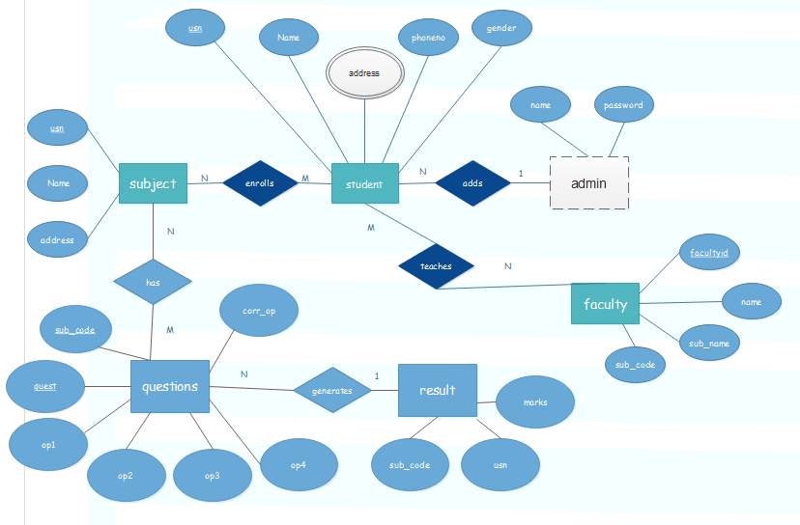

**Schema Diagram:**

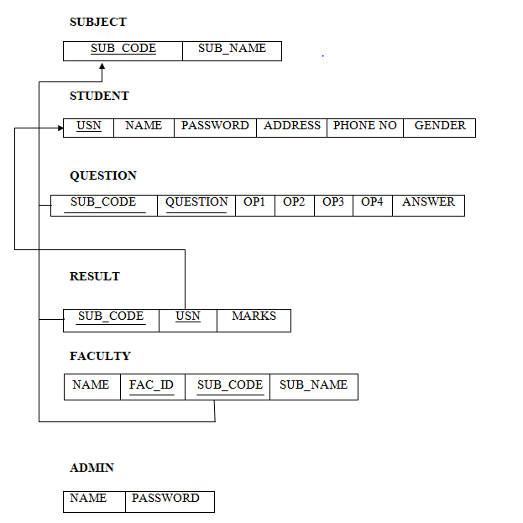

**Chapter 4:**

**IMPLEMENTATIONS AND SCREENSHOTS**

1. Oracle Database is used to store the details.

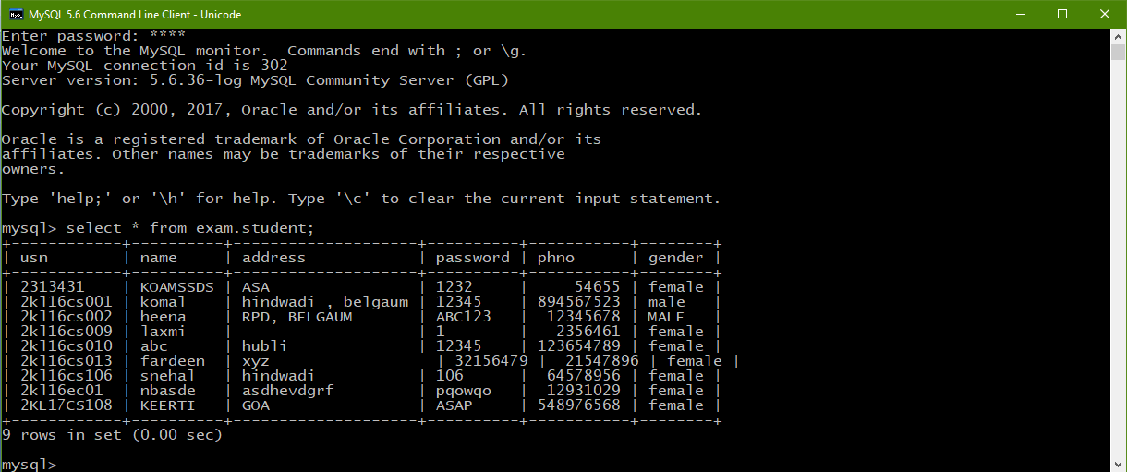

1. Sign in Window for Admin, Faculty, Student

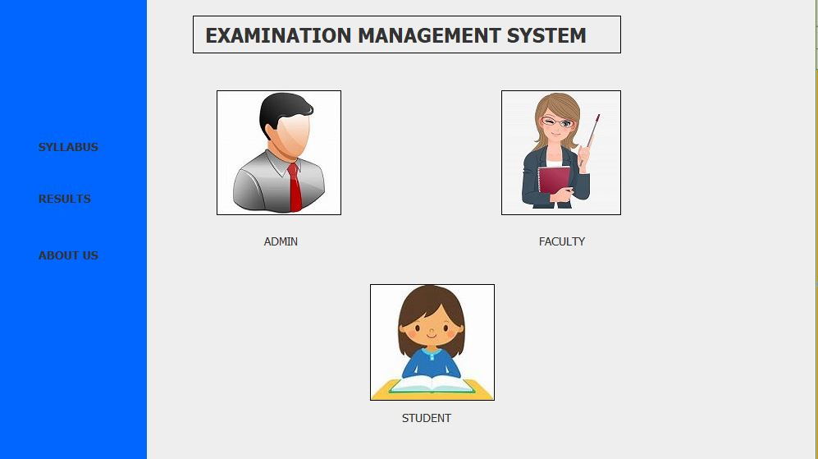

1. Login details for ADMIN

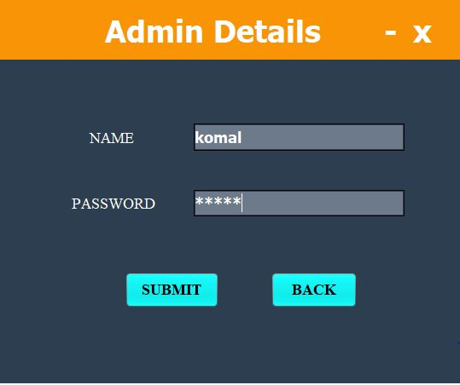

1. Login details for FACULTY

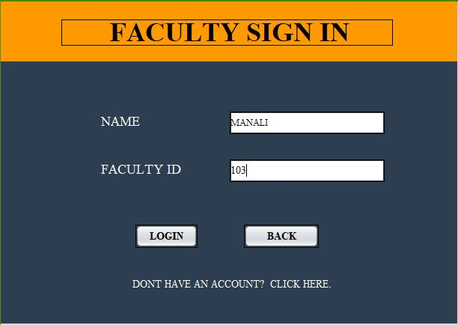

5.Registration panel for student

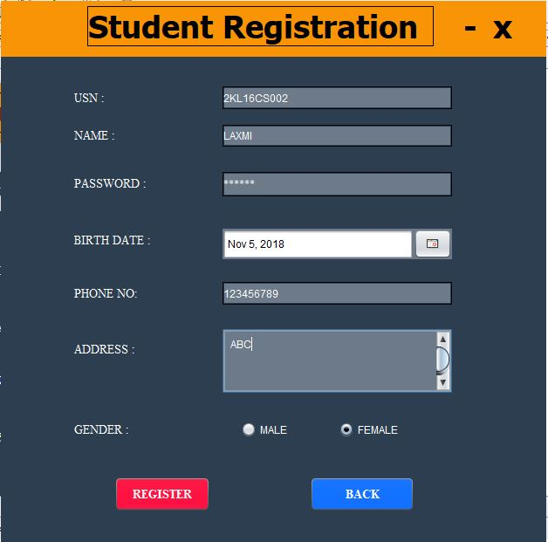

1. Faculty have an option of adding questions.

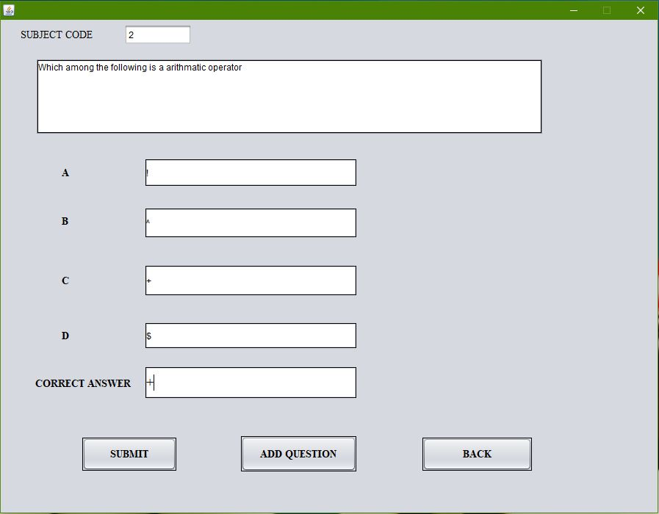

7.Student information.

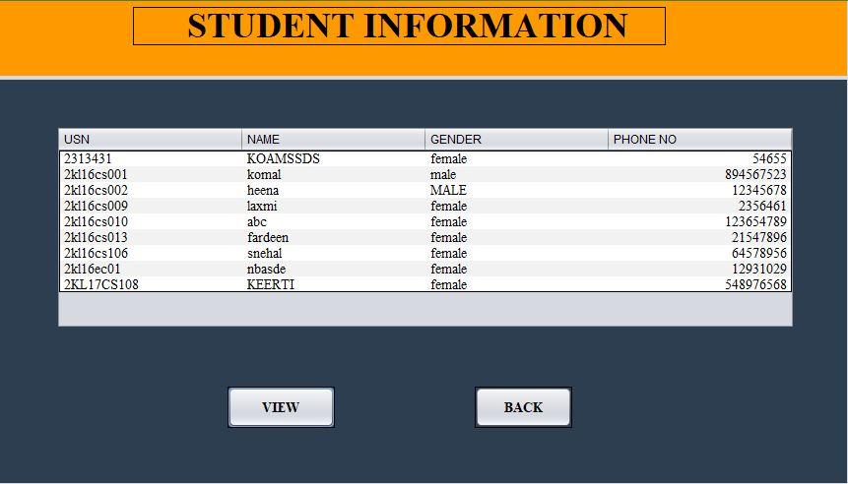

8. Admin can add, delete or view the subjects.

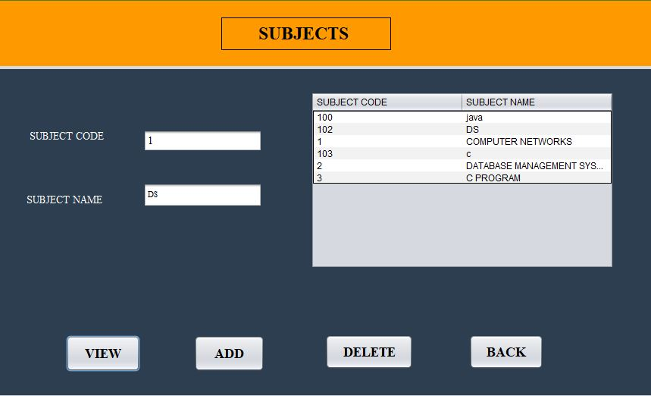

9. Admin can view the details of students, faculty, subject and result.

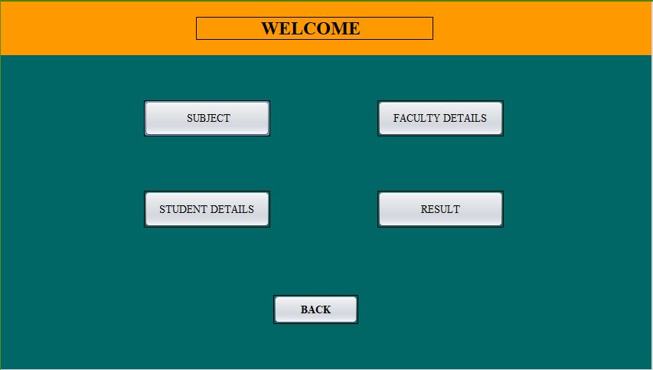

10. Displaying of result.

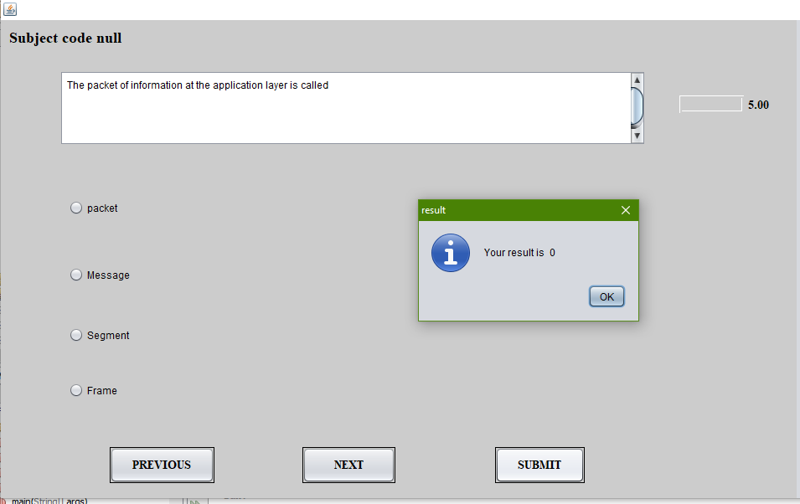

**Chapter 5:**

**CONCLUSION**

* By doing this project it helps number of students to give the exam and displays the results as the test gets over. It is automatically generated by the system. The complete record of student details are maintained for the purpose of reference.

**REFERENCES**

1. Fundamentals of Database Systems, Ramez Elmasri and Shamkant B. Navathe, 7th Edition, 2017, Pearson.
2. Database management systems, Ramakrishnan, and Gehrke, 3rd Edition, 2014, McGrawHill
3. Herbert Schildt: JAVA the Complete Reference, 7th/9th Edition, Tata McGraw Hill, 2007.
4. Jim Keogh: J2EE-TheCompleteReference, McGraw Hill, 2007.
5. www.google.co.in
6. [www.quora.com](http://www.quora.com)
7. <https://stackoverflow.com/>
8. <https://www.w3schools.com/>